Roma 14/06/2025
Statistical Analysis of Consumption Patterns of Italian Citizens
Project by: Davide Cruciani, Luca D’Ingegno, Daniele Maiozzi, Sahmin Mohammad Abdul, Vasile Alessio Raileanu, Sara Rocca.

The goal of this project is to analyze and interpret the consumption behaviors of Italian citizens through statistical analysis. The project focuses specifically on the use of simple regression, multiple regression, and logistic regression models to identify the key variables that influence the spending choices and habits of the population.
The analysis is structured around various socio-economic criteria, including income, number of income earners, employment status, geographic region of residence, transportation expenses, and household composition.
By combining regression methods, the analysis not only estimates the effect of individual independent variables (simple regression) but also considers the interaction between multiple factors (multiple regression) and evaluates the probability of behaviors (logistic regression), thus providing a more comprehensive perspective.

Simple Regression Analysis
To analyze the relationship between consumption and net available income (propensity to consume), a simple linear regression model was used. The dataset contains these two variables:
- Y (dependent variable) = Consumption (C)
- X = Net Available Income (Y.x)
The goal of the analysis is to explore how consumption changes with increasing income and to understand the nature of the correlation between the two variables.
To estimate the simple regression model between consumption and income, the lm() function was used, and the results obtained were subsequently displayed using the summary() function. Below are the lines of code used, along with a brief explanation of their functionality.
- data.Rls <- na.omit(m4[,c("C", "Y.x")]): Creation of a custom dataset for the variables C and Y.x.
- mod_Rls=lm(formula = C ~ Y.x, data= data.Rls): Estimation of the linear regression model.
This line of code uses the lm() function to estimate a linear regression model. The dependent variable is 'consumption' (C), and the independent variable is 'income' (Y.x). The function calculates the regression coefficients that describe the relationship between consumption and income.
- summary(mod_Rls): Display the model results – model summary.
The summary() function is used to obtain a detailed summary of the estimated model. It provides information on the coefficients, standard error, t-values, p-values, and other statistics useful for interpreting the results.

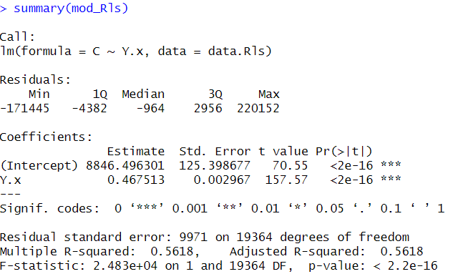
From the analysis of the results, it is evident that the coefficient associated with income is positive and highly significant, with a p-value lower than 2e-16. This suggests that there is a direct relationship between the two variables: as income increases, consumption also increases.
The coefficient of determination, R², is approximately 0.56, indicating that the model explains 56% of the variability in consumption. The remaining 44% can be attributed to other factors not included in the model.
Furthermore, it can be observed that additional data are displayed:
- The distribution of values (Min = -171445, 1Q = -4382, Median = -964, 3Q = 2956, Max = 220152)
- Coefficients, such as:
  - Intercept (b0 = 8846.496), which indicates the expected value of y when x = 0.
  - Y.x (b1 = 0.467), which indicates that for each unit increase in net available income (x), consumption (y) increases by 0.467, or b1. The p-value = 2e^-16 indicates that the coefficient is highly significant.
Subsequently, a scatter plot with the regression line overlaid was created: the data show a generally increasing distribution, consistent with the results obtained from the statistical model.

Graph with the data and regression line
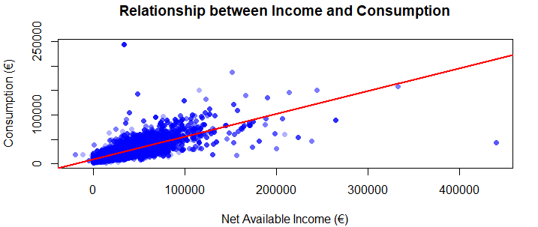
Each point represents an individual (or statistical unit) with a certain income and a certain consumption.
The red line (regression line) is the estimated consumption based on income. The closer the points are to the line, the better the model fits the data.
Finally, the correlation coefficient between the two variables was calculated using the command cor(data.Rls$Y.x, data.Rls$C), which returns a value of 0.7495488 (a high value, indicating a strong correlation). Additionally, model fit statistics, such as SSTOT, SSR, and SSE, were calculated, and the value
of R² (0.5618) was confirmed, as already observed in the model summary, using the command r.quadro = cor(data.Rls$Y.x, data.Rls$C)^2.
Multiple Regression
In the multiple regression analysis, the dependent variable C (Consumption) was analyzed as a function of several explanatory variables:
- NCOMP (Number of family members)
- IRPEF (Region of residence)
- CD1 (Transportation expenses)
- APQUAL (Employment status)
- NPERC (Number of income earners in the household)
The main goal is to assess the impact of multiple variables on consumption while considering their combined effects.
Before proceeding with the estimation of the multiple regression model, the variables were converted into numeric format to ensure proper interpretation by the lm() function in R.
In particular, categorical variables such as region of residence and employment status were transformed into factors and numerically encoded to allow their inclusion in the model alongside continuous variables.
Subsequently, the reference levels for the categorical variables were set manually (e.g., "12 (Lazio)" for ireg and "17 (student)" for apqual), using the command data.Rlm$ireg <- relevel(data.Rlm$ireg, ref = "12"), in order to ensure more consistent and interpretable comparisons within the multiple regression model, specifically regarding the situation of students in Lazio.
At this point, the multiple linear regression model was defined with the following command:
- mod_Rlm = lm(formula = C ~ Y.x + NCOMP + ireg + CD1 + apqual + NPERC, data = data.Rlm)
The lm() function estimates the multiple regression model. The dependent variable is "consumption" (C), while all other variables are the independent variables. The function constructs the linear equation that attempts to explain consumption based on these factors. The variables ireg and apqual are treated as categorical (factor) variables, so dummy variables are created for each level (excluding the reference level). The other variables are numeric (continuous).
- summary(mod_Rlm)
The summary() function is used to obtain a detailed summary of the estimated model. It provides information on the coefficients, standard errors, t-values, p-values, and other statistics useful for interpreting the contribution of each predictor.
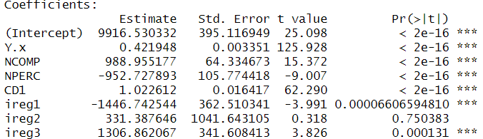
From the analysis of the results, it is evident that the coefficients associated with income are positive and highly significant, with a p-value less than 2e-16. This suggests that there is a direct relationship between the variables. It can also be noted from the output that some levels of the two categorical variables are not very significant.
The coefficient of determination, R², is approximately 0.65, suggesting that the model explains 65% of the variability in consumption. The remaining 35% can be attributed to other factors not included in the model.
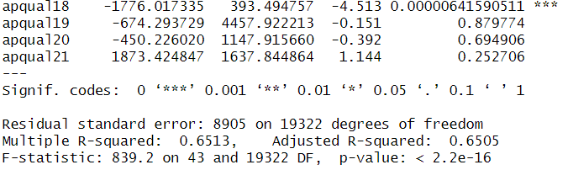

Furthermore, it can be observed that additional data are displayed:
- The distribution of values (Min = -149889, 1Q = -3807, Median = -630, 3Q = 3025, Max = 219156)
- Coefficients, such as:
  - Intercept (b0 = 6982.9618), which indicates the expected value of y when x = 0.
  - Y.x (b1 = 0.4219), which indicates that for each unit increase in net available income (x), consumption (y) increases by b1. In other words: an additional €1 in income generates an increase of 42 cents in consumption. p-value = 2e^-16, indicating that the coefficient is highly significant.
  - NCOMP (b2 = 988.955), which indicates that for each unit increase in the number of family members (x), consumption (y) increases by b2. p-value = 2e^-16, indicating that the coefficient is highly significant.
  - NPERC (b3 = -952.727), which indicates that for each unit increase in the number of income earners (x), consumption (y) increases by b3. p-value = 2e^-16, indicating that the coefficient is highly significant.
  - CD1 (b4 = 1.022), which indicates that for each unit increase in transportation expenses (x), consumption (y) increases by b4. p-value = 2e^-16, indicating that the coefficient is highly significant.
  - Apqual (reference 17 "Student"): Employment status significantly influences consumption levels, with marked differences between groups, divided into some modes that are both positively and negatively significant. For example, from the output, we can see that the unemployed (apqual12) consume on average about €1460 less than students (apqual17), and this difference is statistically significant.
  - Ireg (reference: 12 "Lazio"): The geographical area has a significant influence on consumption, likely due to factors related to the cost of living or regional habits. It is divided into some modes that are both positively and negatively significant. For example, residents of the Lombardy region (ireg3) consume on average about €1306 more than residents of the Lazio region (ireg12), and this difference is statistically significant.
To analyze the relationship between the dependent variable C (consumption) and the main numerical explanatory variables (Y.x, NCOMP, CD1, NPERC), a correlation matrix was calculated using the cor() function.
Specifically, only the continuous numerical variables were considered, as categorical variables (such as ireg and apqual) are not directly compatible with the Pearson correlation calculation. These variables could temporarily be converted into numeric format using the command as.numeric(data.Rlm$ireg), but this might lead to errors or misinterpretations, so these variables were not included in the calculation.
The resulting matrix was then visualized using the corrplot() function, both in numeric format (Figure 1) and through a color-coded plot (Figure 2), to make it easier to read the correlation coefficients and the intensity of the relationships between variables.
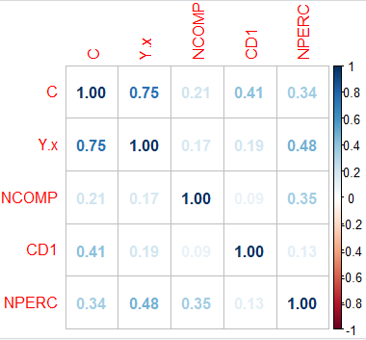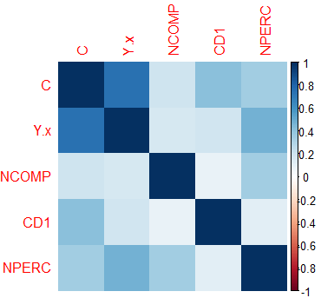
(Figure 1) (Figure 2)
From the analysis of the correlation matrix, a strong positive correlation between consumption (C) and net available income (Y.x) is observed, which is consistent with economic theory. The other variables show weaker correlations with C (consumption), but they are still significant, particularly transportation expenses (CD1) and the number of income earners (NPERC). The correlations among the independent variables remain at low levels, indicating no issues related to multicollinearity. These results justify the inclusion of these variables in the multiple regression model.
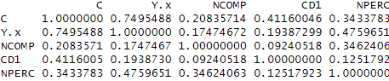

Logistic Regression
Logistic regression is a statistical technique used to analyze the relationship between one or more independent variables and a dependent variable that is binary and categorical (e.g., success/failure, yes/no). Unlike linear regression, which predicts a continuous value, logistic regression estimates the probability that an event will occur. It is particularly useful for classifying observations and evaluating the impact of explanatory variables on the probabilities of a given outcome.
In the logistic regression, the dependent variable dislav_bin (experiences of unemployment lasting more than 6 months) was analyzed as a function of two explanatory variables:
- spesecon (regular monthly expenses in cash)
- asnonoc (previous employment status before pension/unemployment)
In logistic regression, the dependent variable y is a binary dummy variable that can take values between 0 and 1. Therefore, the dislav variable was converted into a binary form using the command: data.log$dislav_bin <- ifelse(data.log$dislav == 1, 1, 0)

At this point, the regression model was defined with the following command:
- mod_log = glm(dislav_bin ~ spesecon + asnonoc, family = binomial, data = data.log)
This estimates a binary logistic regression model, analyzing the combined effect of two independent variables (spesecon and asnonoc) on the probability that the event coded as 1 in the dependent variable dislav_bin occurs. It provides estimated coefficients that indicate how each variable influences (positively or negatively) the probability of the outcome, while also allowing us to verify whether the two variables have a statistically significant effect on the outcome, taking each other into account.

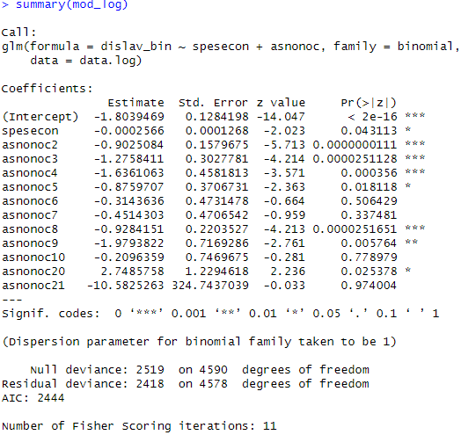
From the analysis of the results, it appears that some categories of asnonoc significantly influence the probability of the event (dislav_bin), as indicated by the low p-value. Conversely, others are not significant. Additionally, spesecon has a negative and significant effect, although small.
The model shows a slight improvement compared to the null model (deviance reduced from 2519 to 2418), but not enough to claim that it has strong explanatory power. In practice, it explains only a limited portion of the variability in the dislav_bin variable.

After estimating the logistic regression model, we calculated the predicted probabilities that an individual has had at least one experience of unemployment lasting more than six months (dislav_bin = 1), based on their monthly expenses (spesecon) and previous employment status (asnonoc):
- predict.probs2 = predict(mod_log, type = "response")
The probabilities obtained were then transformed into predicted classes (0 = "no experience > 6 months", 1 = "at least one experience > 6 months") using a standard classification threshold of 0.5:
- p.soglia = 0.5
- predict.class = ifelse(predict.probs2 >= p.soglia, 1, 0)
This procedure allows for transitioning from a probabilistic model to a classification model, which is essential for evaluating performance through metrics such as accuracy, sensitivity, specificity, and for constructing the confusion matrix.
After transforming the predicted probabilities into binary classes (0/1), we evaluated the quality of the model’s predictions using a confusion matrix, which compares the predicted classes with the observed classes.
- conf.mat = table(Predicted = predict.class,
Osserved = as.numeric(data.log$dislav) - 1)
- print(conf.mat) # Display the calculated confusion matrix

- TN = conf.mat[0, 0] # True Negatives
- TP = conf.mat[1, 1] # True Positives
- FN = conf.mat[1, 1] # False Negatives
- FP = conf.mat[1, 0] # False Positives

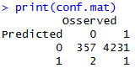

From this table, the following indicators were derived:
- Sensitivity (True Positive Rate - sensitivity) = 0.00023, which indicates the proportion of positive cases correctly identified by the model.
- Specificity (True Negative Rate - specificity) = 0.994, which indicates the proportion of negative cases correctly identified.
- Accuracy = 0.0779, which indicates the rate of correct observations.

By lowering the classification threshold from 0.5 to 0.1, the model showed a clear increase in sensitivity (from 0.02% to 41.1%), indicating a greater ability to correctly identify individuals with unemployment experiences. However, this resulted in a decrease in specificity (from 99.4% to 34.3%) and an increase in false positives. Overall accuracy improved to 40.6%, suggesting that a lower threshold might be preferable in contexts where it is a priority not to overlook positive cases.
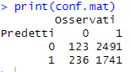

Next, the ROC curve was plotted, showing the behavior of the True Positive Rate (TPR) as a function of the False Positive Rate (FPR), with the classification threshold varying. This is useful for evaluating the discriminative ability of the model, using the following commands:
Calculate and visualize the ROC curve
- pred <- prediction(predict_probs, data.log$dislav_bin)
- perf <- performance(pred, "tpr", "fpr")
ROC curve plot with AUC label
- plot(perf, col = "blue", lwd = 2, main = "ROC Curve - Model Performance")
- abline(a = 0, b = 1, lty = 2, col = "black")
Calculate and display the AUC
- auc_value <- performance(pred, "auc")@y.values[[1]]
- polygon(c(0, x_vals, 1), c(0, y_vals, 0), col = rgb(0.1, 0.4, 0.9, 0.1), border = NA)
- text(0.6, 0.2, paste("AUC =", round(auc_value, 4)), cex = 1.2)

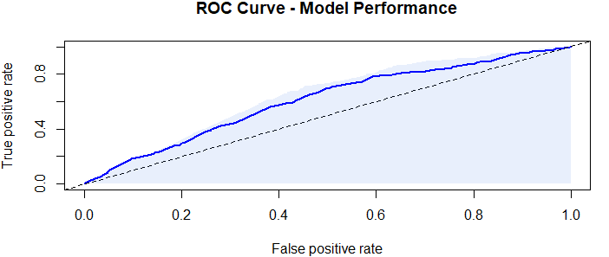
The area under the curve (AUC) was found to be 0.6481, indicating a moderate ability of the model to distinguish between individuals with and without experience of unemployment lasting more than six months.

Clustering
Clustering is the process of organizing a set of objects or data into homogeneous groups, such that objects within the same group are more similar to each other (based on a specific metric or measure of similarity/dissimilarity) than to objects in other groups. The main goal of clustering is to find inherent structures in the data by grouping elements that share similar characteristics or tendencies.
We applied a K-means clustering procedure on two quantitative variables (the same used in the simple regression model):
- C (Consumption)
- Y.x (Net Available Income)
The goal was to identify homogeneous subgroups of individuals based on their economic behavior. The clustering was performed using the following commands:
- set.seed(123)
- kmeans_result <- kmeans(data_regression_simple, centers = 3)
- data_regression_simple$cluster <- kmeans_result$cluster
- plot(data_regression_simple$C, data_regression_simple$Y.x,
col = data_regression_simple$cluster, pch = 16,
xlab = "Consumption (€)", ylab = "Net Available Income (€)",
main = "K-means Clustering: Consumption vs Income")

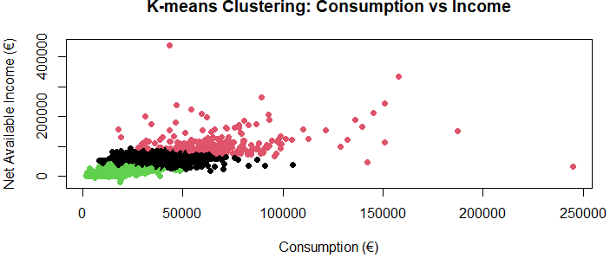

The algorithm identified 3 distinct clusters, visible in the scatter plot, which show significant differences in the combination of consumption levels and income availability.
Specifically, a green group characterized by low consumption and low income, a black group characterized by moderate consumption and average income, and a red group characterized by high consumption and high income. The pink cluster shows high dispersion. This division suggests the existence of differentiated economic behaviors based on income levels.

Boxplot
The use of a boxplot is particularly useful for comparing multiple groups and identifying any structural differences or asymmetries. In fact, it allows for a graphical summary of the distribution of a quantitative variable, highlighting central values, dispersion, and the presence of outliers.
A boxplot was created to analyze the distribution of consumption (C) based on the geographic region of residence (AREA3: North, Center, South), using the following command:
- boxplot(C ~ AREA3, data = m4, names = c("North", "Center", "South")
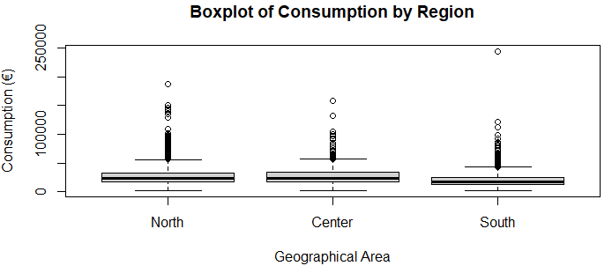

The graph shows a similar distribution across the regions, with slight differences in the medians.
The presence of numerous outliers indicates that in all regions, there are individuals with very high consumption levels compared to the rest of the group.
These anomalies push the scale upwards and suggest a possible positive skew in the distribution of consumption.
The analysis of the boxplots highlights that it is not so much the North that stands out for high consumption, but rather the South, which shows lower average consumption levels compared to the other two regions.
The medians and interquartile range of the South are indeed lower, suggesting a distribution more concentrated towards the lower end. The North, however, is slightly above the Center (and visibly above the South), indicating a generally higher level of consumption, although the difference compared to the Center is modest.
Conclusions
The statistical analysis conducted has highlighted that net income is the main factor influencing consumption, as confirmed by both the simple and multiple regressions. The latter also allowed for the evaluation of the effects of variables such as the number of family members, employment status, and geographic region, improving the model's ability to explain the variability in consumption (R² ≈ 0.65).
Logistic regression, despite having limited predictive power, revealed a connection between certain employment conditions and the probability of unemployment experiences. Clustering identified groups with distinct economic behaviors, while the boxplots showed generally lower consumption in the South compared to the North and Center.
Overall, the results obtained were consistent with our initial expectations, providing a clear and structured view of the factors influencing consumption in Italy.

